ASNT6119-KMF
32.5Gbps Advanced Driver/Amplifier
- High-speed limiting amplifier with selectable built-in pre-emphasis
- Four pre-emphasis taps with externally controlled weight and inversion
- Adjustable data output amplitude and eye quality
- Single-ended output data eye cross point adjustment
- Optional main clock frequency multiplier by 2
- Main clock duty cycle indicators located before and after the multiplier
- Opposite and parallel adjustment of the main clock and data delays
- Additional clock input
- Fully differential CML input and output data, and clock interfaces
- Selectable main or additional clock at the output with adjustable amplitude
- Standard CMOS 3-wire interface for digital controls
- On-chip linear temperature sensor
- Two power supplies: negative -4.3V and floating positive +3.5V
- Average power consumption: 4.0W
- Custom CQFP 64-pin package
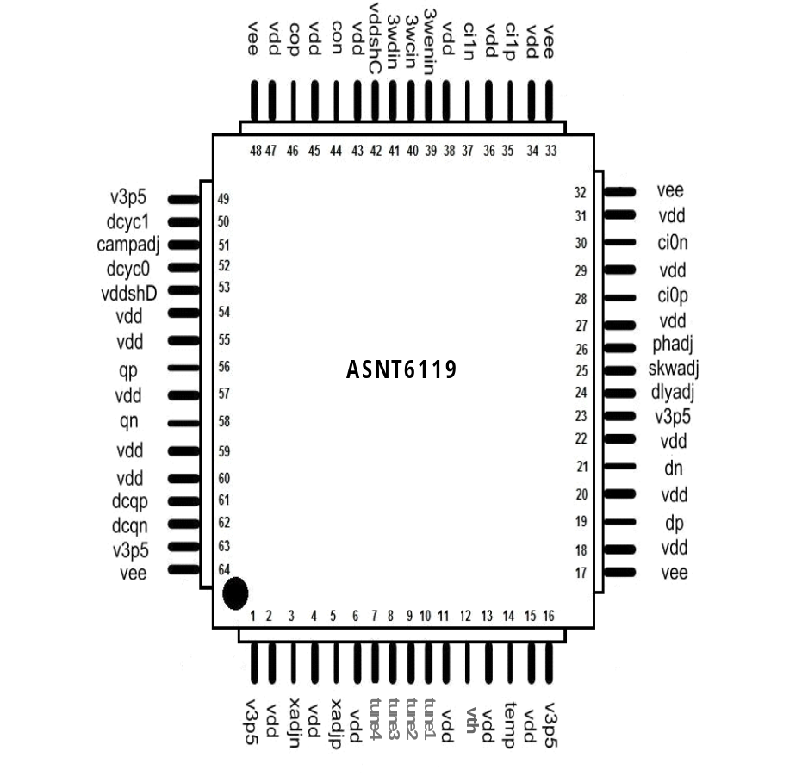

DESCRIPTION
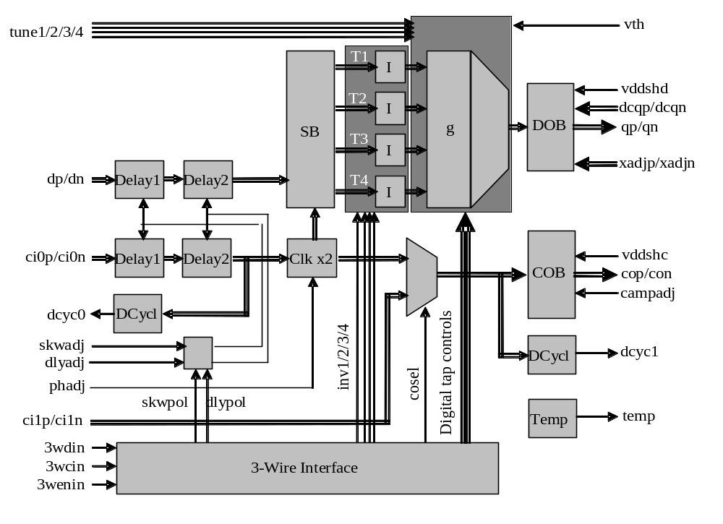
Fig. 1. Functional Block Diagram
The ASNT6119-KMF SiGe IC shown in Fig. 1 is an advanced programmable driver-amplifier (ADA) with built-in 4-tap pre-emphasis. The ADA generates a combination of four delayed copies of its input differential data signal dp/dn with certain user-controlled weights and polarities. The copies are created in a 4-bit shift register activated by the ADA’s internal high-speed clock signal (see Sampling Block and Taps). This clock signal is a copy of the main input clock ci0p/ci0n with either matching or doubled (multiplied-by-2) frequency. In the multiply-by-2 clock mode, the duty cycles of the input and internal clock signals are monitored, and the output duty cycle can be adjusted through the external control port phadj (see Clock Multiplier). For the part’s correct operation, the input data rate in Gbps should be equal to the internal clock frequency in GHz.

Input clock and data signals can be delayed in the same or opposite directions to ensure their correct phase relation at the inputs of the shift register and at the chip outputs (see Input Delay Section). The ADA can accept one additional clock signal ci1p/ci1n and deliver it to the output port cop/con instead of the main clock ci0p/ci0n, thus operating as a clock buffer (see Additional Input Clock and Clock Output Buffer).

The part’s I/Os support CML logic interface with on-chip 50Ohm termination to ground. External 50Ohm termination is also required. DC-coupling for data and clock output ports is strongly recommended. The input ports can use DC or AC coupling. Differential input clock and data are strongly recommended. Amplitude and peaking in the clock and data output signals can be externally adjusted. Both single-ended data output signals also have controlled DC common-mode levels and eye crossing points (see Data Output Buffer).

All operational modes of the chip are controlled through a 3-wire serial interface. For more details see 3-Wire Interface Control Block.

The chip operates from one negative power supply (positive pin connected to external Ground, negative pin vee = -4.3V) and one floating positive power supply (negative pin connected to vee and positive pin v3p5 = 3.5V). It is recommended to keep the relative deviation of v3p5 from Ground within less than ±0.1V.

Input Delay Section
As shown in Fig. 1, the ADA accepts differential input data dp/dn and clock ci0p/ci0n signals and inserts them both into identical variable delay blocks Delay1 and Delay2 that can be adjusted in parallel or opposite modes depending on the polarity of internal digital signals skwpol and dlypol (“0”=parallel, “1”=opposite) provided by the 3-Wire Interface block. The Delay1 blocks are controlled by the analog voltage skwadj. The Delay2 blocks are controlled by the analog voltage dlyadj.

It should be noted that the delay settings may affect the multiplied-by-2 clock’s duty cycle and should be tuned for each specific case.

Clock Multiplier
The clock doubler Clkx2 uses a “delay and XOR” mechanism to create output clock pulses from each edge of the input clock ci0p/ci0n. The multiplier is intended for operation with input clock signals within a certain frequency range specified in ELECTRICAL CHARACTERISTICS. Analog control voltage phadj performs a dual function of multiplier activation and linear phase control. Voltages within the linear control range activate the multiplication function and are used for tuning the block’s internal delay in order to achieve 50% duty cycle of the multiplied clock. Voltages below the switch-off threshold disable the multiplication function and allow for direct passing of the input clock to the multiplier’s output.

Two duty cycle control blocks DCycl are used for monitoring the clock pulse shapes before and after the multiplier. The first block is positioned before the multiplier and delivers single-ended analog voltage dcyc0 that indicates the input clock’s duty cycle deviation from 50%. The second block is positioned after the multiplier and delivers a similar signal dcyc1 for the output clock. Both generated output voltages can be used in combination with phadj input within external control loops for getting an optimal shape of the multiplied clock.

It should be noted that the duty cycle of the multiplied clock may depend on the delay settings (see Input Delay Section).

Additional Input Clock and Clock Output Buffer
The ADA can also accept an additional input clock signal ci1p/ci1n and deliver it to the clock output. This allows the IC to operate solely as a clock amplifier where the output clock signal’s amplitude supplied by output buffer COB can be adjusted using the analog signal campadj. The amplitude changes from its minimum value (campadj = switch-off threshold) to its maximum value (campadj = maximum). COB can also be completely disabled by applying campadj voltage below the switch-off threshold.

Either ci0 or ci1 clock signals can be processed by the output buffer COB. Selection of the input clock is accomplished through the digital control signal clock select (“0” - ci0, “1” - ci1) delivered by the 3-wire interface block.

The quality of the output signal’s shape can be optimized using the external control vddshc. This voltage controls peaking on the falling edge of the output signal. More positive voltages correspond to higher peaking.

Sampling Block and Taps
Sampling block SB is essentially a 4-bit shift register that generates 4 delayed data streams T1-T4 needed for the ADA’s 4-tap pre-emphasis capability. As stated above, the analog control voltage dlyadj is used to adjust the phase relationship between clock and data to ensure optimum sampling in SB. The four samples of the data stream with certain weights and polarities are delivered to the output buffer via four identical channels.

The polarity of the data streams can be independently inverted by circuit blocks I under control of four signals inv1/inv2/inv3/inv4 (“0”=direct, “1”=inverted) provided by the 3-wire interface.

This version of the ADA has 4 Taps (1, 2, 3, and 4) designed as 11 parallel buffers with a common load that are combined into a single output driver. Each buffer has its maximum amplitude equal to 1/8th of the optimal total output amplitude A_{out}. The first 7 buffers can be assigned to one of 2 Taps or switched off completely using digital signals provided by the 3-wire interface as shown in Table 1. For detailed interface mapping, see the 3-Wire Interface Control Block section below.
Table 1. Buffer’s Assignment to Taps
Buffers | 1 | 2 | 3 | 4 | 5 | 6 | 7 | 8 | 9 | 10 | 11
Taps | 1/2 | 1/2 | 3/2 | 3/2 | 3/2 | 4/2 | 4/2 | 1 | 2 | 3 | 4
Amplitude | Constant, 0 or 1/8th of A_{out} |  |  |  |  |  |  | From 0 to A_{analog} = A_{out}/8
Control | Digital |  |  |  |  |  |  | Analog
The last 4 buffers are assigned to one Tap each and are linearly controlled by four external voltages tune1/tune2/tune3/tune4 from minimum (0) to maximum (A_{analog}) amplitude that is approximately equal to 1/8th of A_{out}. The actual value of the amplitude A_{analog} available for the analog controls can be adjusted through the external control voltage vth. The calibration procedure is described in the Application Notes.

It should be noted that the output amplitude may exceed the optimal value by up to 3/8th of A_{out}, if more than one analog buffer is activated. It is recommended to avoid such situations by the appropriate assignment of Tap weights.

For example, if all seven digital buffers are activated, the total value of the analog amplitude should not exceed 1/8th of A_{out}. This means that one analog buffer can be fully switched on while the controls of the three remaining analog buffers should stay at minimum. If two analog buffers are required, then one of them can be assigned a weight of A₁ ≤ 1/8th of A_{out} and the other one can have a weight of A₂ ≤ 1/8th-A₁ .

The recommended algorithm of the weight assignment is described in the ASNT6119 Application Notes.

Data Output Buffer
Data output buffer DOB includes several features to tune the output data signal generated by the ADA.

The quality of the output signal shape can be optimized using the control voltage vddshd similar to what is described in the Additional Input Clock and Clock Output Buffer section above.

Optimized output eyes with a 625mV amplitude delivered from one Tap at data rates of 28Gb/s and 32Gb/s are shown in Fig. 2 and Fig. 3 respectively. Fig. 4 to Fig. 6 show this part’s capabilities for driving a PAM4 signal.

Differential analog control voltage xadjp/xadjn can be utilized to adjust the crossing points of single-ended output eyes. At the default state of xadjp = xadjn = 0V, the crossing points in both direct and inverted eyes should be centered. The crossing points are moving up in the direct eye and down in the inverted eye if xadjp = -xadjn > 0, or in the opposite directions if xadjp = -xadjn < 0.

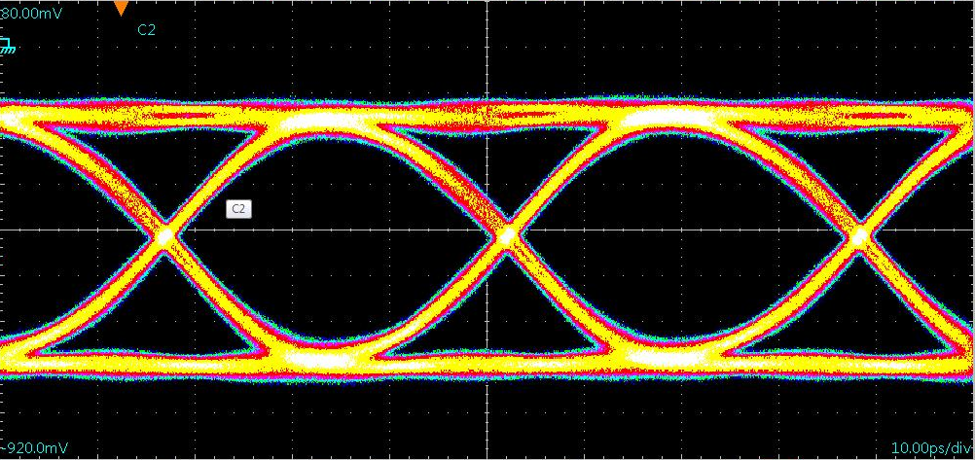
Fig. 2. 1-Tap Output Eye at 28Gb/s Data Rate
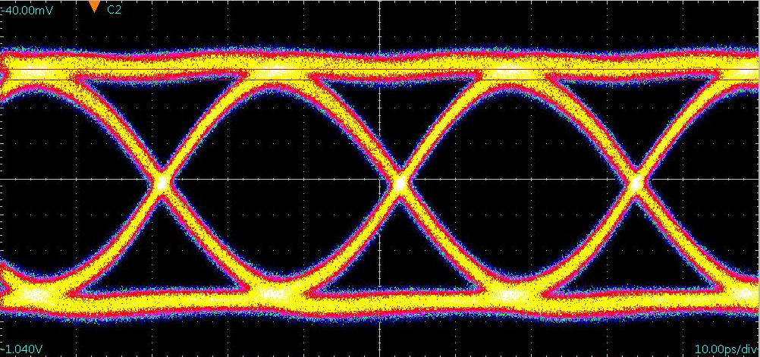
Fig. 3. 1-Tap Output Eye at 32Gb/s Data Rate
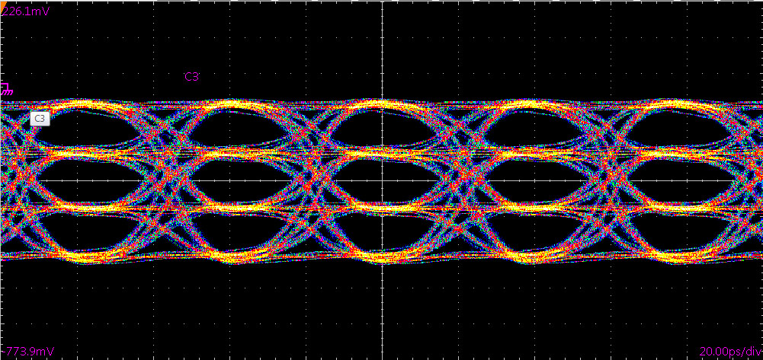
Fig. 4. PAM4 Output Eye Diagram at 25.8Gb/s Data Rate

Finally, 1.0KOhm resistors are attached to both data outputs qp and qn to provide DC shifting of the output signals. Access to the resistors is available through control pins dcqp/dcqn.

Temperature Sensor
A linear temperature sensor is included on chip. Its behavior is illustrated in Fig. 7 below. The demonstrated voltage has been generated on the internal 11KOhm resistor connected to vdd.

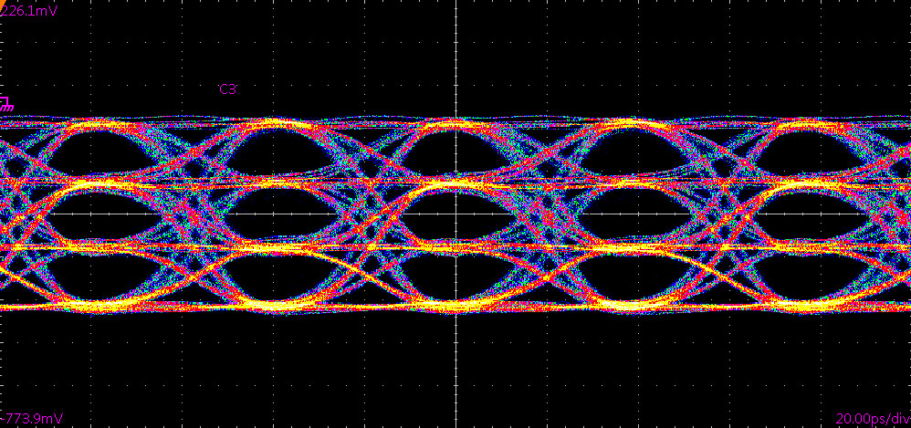

Fig. 5. PAM4 Output Eye Diagram at 28Gb/s Data Rate

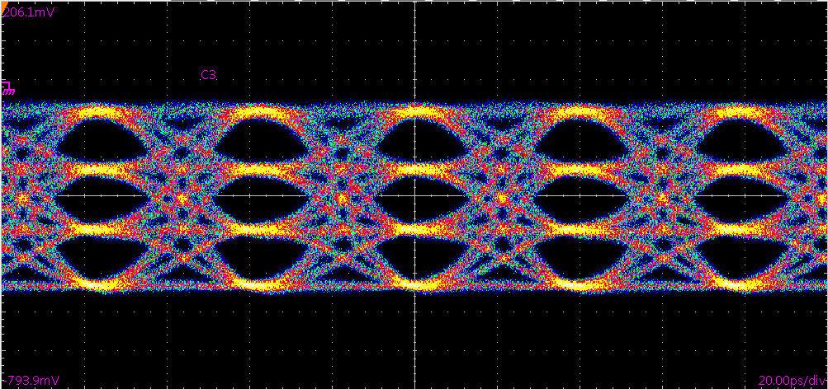
Fig. 6. PAM4 Output Eye Diagram at 28Gb/s Data Rate
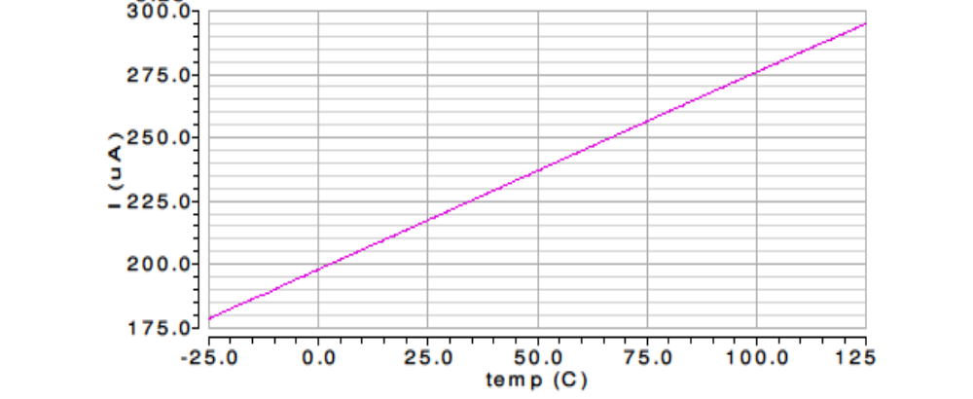
Fig. 7. Temperature Sensor’s Characteristic

3-Wire Interface Control Block
To reduce the physical number of digital control inputs to the ADA, a 32-bit shift register with a 3-wire input interface has been included on chip. The digital control bits applied through 3wdin input are latched in and shifted down the register by negative edges of low-speed clock 3wcin (Bit 0/MSB first). Write enable signal 3wenin must be set to logic “1” during the data read-in phase and then set to logic “0” to retain the shifted in values after 32 clock periods of 3wcin. Table 2 below maps the input 32-bit word to the internal digital control signals.
Table 2. 3-Wire Interface Bit Map
Bit # | Function | State at Bit=”1”/”0”
0, MSB | Activation of additional 1/2 pre-buffer current in one of the Taps. Must be ON if the amplitude in the corresponding Tap is more than half of its maximum value (more than 1/16th of the full output amplitude, or A_{out}/16). | ON/OFF in Tap 4
1 |  | ON/OFF in Tap 3
2 |  | ON/OFF in Tap 2
3 |  | ON/OFF in Tap 1
4 | Activation of analog-controlled sections of the Taps including the corresponding output drivers and 1/2 pre-buffer currents. | ON/OFF in Tap 4
5 |  | ON/OFF in Tap 3
6 |  | ON/OFF in Tap 2
7 |  | ON/OFF in Tap 1
8 | Buffer 7 activation (A_{out}/8 for Tap 2 or Tap 4 as defined by Bit 16) | ON/OFF
9 | Buffer 6 activation (A_{out}/8 for Tap 2 or Tap 4 as defined by Bit 17) | ON/OFF
10 | Buffer 5 activation (A_{out}/8 for Tap 2 or Tap 3 as defined by Bit 18) | ON/OFF
11 | Buffer 4 activation (A_{out}/8 for Tap 2 or Tap 3 as defined by Bit 19) | ON/OFF
12 | Buffer 3 activation (A_{out}/8 for Tap 2 or Tap 3 as defined by Bit 20) | ON/OFF
13 | Buffer 2 activation (A_{out}/8 for Tap 2 or Tap 1 as defined by Bit 21) | ON/OFF
14 | Buffer 1 activation (A_{out}/8 for Tap 2 or Tap 1 as defined by Bit 22) | ON/OFF
15 | Not used
16 | Buffer 7 assignment to Tap 2 or Tap 4 |  | Tap 2 / Tap 4
17 | Buffer 6 assignment to Tap 2 or Tap 4 |  | Tap 2 / Tap 4
18 | Buffer 5 assignment to Tap 2 or Tap 3 |  | Tap 2 / Tap 3
19 | Buffer 4 assignment to Tap 2 or Tap 3 |  | Tap 2 / Tap 3
20 | Buffer 3 assignment to Tap 2 or Tap 3 |  | Tap 2 / Tap 3
21 | Buffer 2 assignment to Tap 2 or Tap 1 |  | Tap 2 / Tap 1
22 | Buffer 1 assignment to Tap 2 or Tap 1 |  | Tap 2 / Tap 1
23 | Not used
24 | Selection of the clock (C0 or C1) to be sent to the output |  | C1 / C0
25 | Selection of the data and clock short delay (opposite or parallel) |  | Parallel/Opposite
26 | Selection of the data and clock long delay (opposite or parallel) |  | Parallel/Opposite
27 | Activation of the Tap 4 data inversion |  | ON/OFF
28 | Activation of the Tap 3 data inversion |  | ON/OFF
29 | Activation of the Tap 2 data inversion |  | ON/OFF
30 | Activation of the Tap 1 data inversion |  | ON/OFF
31, LSB | Not used

This chip includes a standard 3-wire interface with a 100KOhm terminations to vdd for all interface inputs.

TERMINAL FUNCTIONS

TERMINAL |  |  | Description
Name | No. | Type | Description
High-Speed I/Os
dp | 19 | CML input with internal SE 50Ohm termination to vcc | Differential high-speed data input
dn | 21 | CML input with internal SE 50Ohm termination to vcc | Differential high-speed data input
ci0p | 28 | CML input with internal SE 50Ohm termination to vcc | Differential high-speed main clock input
ci0n | 30 | CML input with internal SE 50Ohm termination to vcc | Differential high-speed main clock input
ci1p | 35 | CML input with internal SE 50Ohm termination to vcc | Differential high-speed additional clock input
ci1n | 37 | CML input with internal SE 50Ohm termination to vcc | Differential high-speed additional clock input
cop | 46 | CML output requires external SE 50Ohm termination to vcc | Differential high-speed clock output
con | 44 | CML output requires external SE 50Ohm termination to vcc | Differential high-speed clock output
qp | 56 | CML output requires external SE 50Ohm termination to vcc | Differential high-speed data output
qn | 58 | CML output requires external SE 50Ohm termination to vcc | Differential high-speed data output
Low-Speed I/Os
3wenin | 39 | 3.3V  CMOS  input | Enable input signal for 3-wire interface
3wcin | 40 | 3.3V  CMOS  input | Clock input signal for 3-wire interface
3wdin | 41 | 3.3V  CMOS  input | Data input signal for 3-wire interface
Analog Control Voltage Inputs
xadjp | 5 | Analog input with 100KOhm termination to vdd | Output data eye cross point adjustment, Differential
xadjn | 3 | Analog input with 100KOhm termination to vdd | Output data eye cross point adjustment, Differential
tune4 | 7 | Analog input with 100KOhm termination to vdd | Tap 4 analog weight adjustment, SE
tune3 | 8 | Analog input with 100KOhm termination to vdd | Tap 3 analog weight adjustment, SE
tune2 | 9 | Analog input with 100KOhm termination to vdd | Tap 2 analog weight adjustment, SE
tune1 | 10 | Analog input with 100KOhm termination to vdd | Tap 1 analog weight adjustment, SE
vth | 12 | Analog input with 100KOhm termination to vdd | Threshold voltage for the analog maximum value adjustment
dlyadj | 24 | Analog input with 100KOhm termination to vdd | Adjustment of Delay 2 blocks, SE
skwadj | 25 | Analog input with 100KOhm termination to vdd | Adjustment of Delay 1 blocks, SE
phadj | 26 | Analog input with 100KOhm termination to vdd | Clock multiplier delay (output duty cycle) adjustment, SE
campadj | 51 | Analog input with 100KOhm termination to vdd | Clock output amplitude adjustment, SE
dcqp | 61 | Analog input | Direct data output common-mode DC shift, SE
dcqn | 62 | Analog input | Inverted data output common-mode DC shift, SE
Analog Control Indicators
temp | 14 | Analog output | Linear temperature-dependent voltage output with internal 11KOhm termination to vdd.
dcyc1 | 50 | Analog output | Linear voltage indicating output clock duty cycle
dcyc0 | 52 | Analog output | Linear voltage indicating main input clock duty cycle

Supply And Termination Voltages
Name | Description | Pin Number
vdd | External ground | 2, 4, 6, 11, 13, 15, 18, 20, 22, 27, 29, 31,  34, 36, 38, 43, 45, 47, 54, 55, 57, 59, 60
vee | -4.3V negative power supply | 17, 32, 33, 48, 64
v3p5 | +3.5V positive power supply  Negative pin to vee | 1, 16, 23, 49, 63
vddshC | Output clock and data peaking adjustment Positive power supply. Negative pin to vee | 42
vddshD |  | 53

ABSOLUTE MAXIMUM RATINGS
Caution: Exceeding the absolute maximum ratings shown in Table 3 may cause damage to this product and/or lead to reduced reliability. Functional performance is specified over the recommended operating conditions for power supply and temperature only. AC and DC device characteristics at or beyond the absolute maximum ratings are not assumed or implied. All min and max voltage limits are referenced to ground (assumed vdd).
Table 3. Absolute Maximum Ratings
Parameter | Min | Max | Units
Negative Supply Voltage (vee) |  | -4.8 | V
Positive Supply Voltage (v3p5) |  | 3.8 | V
Power Consumption |  | 5.0 | W
RF Input Voltage Swing (SE) |  | 1.2 | V
Case Temperature |  | +90 | ºC
Storage Temperature | -40 | +100 | ºC
Operational Humidity | 10 | 98 | %
Storage Humidity | 10 | 98 | %

ELECTRICAL CHARACTERISTICS
PARAMETER | MIN TYP MAX | UNIT | COMMENTS
General Parameters
vee | -4.1 -4.3 -4.5 | V
vdd | 0.0 | V | External ground
v3p5 | 3.4 3.5 3.6 | V | “-“ pin to vee
I_{-4.3} | 120 220 | mA | Depending on the settings of the clock multiplier and the clock and data amplitudes¹⁾
I_{v3p5} | 850 1020 | mA
Power | 3.5 4.0 4.5 | W
Junction temperature | 0 50 100 | °C
Data input (dp/dn)
Rate | 1.0 32.5 | Gb/s
SE Swing | 50 200 500 | mV | Peak-to-peak
CM Level | vdd-(SE swing)/2
Clock inputs (ci0p/ci0n, ci1p/ci1n)
Frequency (C0 input) | 1.0 17 | GHz | Fx1 mode, any skwadj and dlyadj
Frequency (C0 input) | 4.0 16.25 | GHz | Fx2 mode, skwadj and dlyadj need tuning
SE Swing | 50 200 500 | mV | Peak-to-peak
CM Level | vdd-(SE swing)/2
Data output (qp/qn)
Rate | 1.0 32.5 | Gbps
SE Swing | 0.0 1250 | mV | Peak-to-peak
CM Level | vdd-0.1 vdd-0.75 | V | Depends on the amplitude²⁾
Rise/Fall Times | 12 13 14 | ps | 20%-80%
Clock output (cop/con)
SE Swing, max | 530 920 | mV | Pk-pk, 1.0-17GHz
SE Swing, max | 160 400 | mV | Pk-pk, 18-32GHz
CM Level | vdd-0.05 vdd-0.55 | V | Depends on the amplitude³⁾
Rise/Fall Times | TBD | ps | 20%-80%
SE tuning ports (tune1/2/3/4, skwadj, dlyadj, phadj, campadj)
Linear control voltage | vdd-2 vdd | V
Switch-off threshold | vdd-2 | V
Cross point control (xadjp/xadjn)
Differential voltage range | vdd-8.0 vdd+8.0 | V | ±4V at each input
CM Level | vdd
Current in/out of the pin | +4 / -4 | mA | at +4V / -4V
Threshold control (vth)
Voltage range | vdd-2 vdd | V
DC common mode voltage control (dcqp/dcqn)
Voltage range | vee vdd | V
PARAMETER | MIN TYP MAX | UNIT | COMMENTS
Externally Controlled Operational Ranges
Clock-to-Data skew | -30 +30 | ps | opposite skwadj control
Clock and Data delay | 0 +30 | ps | paralllel skwadj control
Clock-to-Data skew | -45 +45 | ps | opposite dlyadj control
Clock and Data delay | 0 +45 | ps | paralllel dlyadj control
Output eye cross point | -25 +25 | % | of the eye amplitude

PARAMETER | MIN TYP MAX | UNIT | COMMENTS
Variable supply voltages (vddshc, vddshd)
Voltage range | 2.8 4.3 | V | “-“ pin to vee
I_{vddshd} | 2.2 | mA | All 4 taps active
I_{vddshc} | 1.1 | mA
Duty Cycle Indicator (dcyc0/dcyc1)
Voltage range | vdd-3.3 vdd-0.8 | V
Temperature Sensor (temp)
Voltage range | vdd-3.3 vdd-2.3 | V
3-Wire Inputs (3wdin, 3wcin, 3wenin)
High voltage level | vdd-0.2 vdd | V
Low voltage level | vdd-3.3 vdd-3.1 | V
Clock speed | 350 400 | MHz

Power Supply Currents

(Preliminary Data, for Reference Only)

co amplitude | q amplitude | Clock multiplier | I_{-4.3}, mA | I_{v3p5}, mA
min | min | off (Fx1) | 120 | 850
min | min | on (Fx2) | 120 | 920
min | max | off (Fx1) | 180 | 880
min | max | on (Fx2) | 180 | 950
max | min | off (Fx1) | 160 | 930
max | min | on (Fx2) | 160 | 1000
max | max | off (Fx1) | 220 | 950
max | max | on (Fx2) | 220 | 1020

Data Output Common Mode Voltage Levels

(Preliminary Data, for Reference Only)

Amplitude |  |  | V_{CM}, V | Amplitude |  |  | V_{CM}, V
Total, mV | Digital | Analog, mV | V_{CM}, V | Total, mV | Digital | Analog, mV | V_{CM}, V
150 | 0 | min | vdd-0.089 | 790 | 4A_{out}/8 | min | vdd-0.461
150 | A_{out}/8 | max | vdd-0.182 | 790 | 5A_{out}/8 | max | vdd-0.554
310 | A_{out}/8 | min | vdd-0.182 | 950 | 5A_{out}/8 | min | vdd-0.554
310 | 2A_{out}/8 | max | vdd-0.275 | 950 | 6A_{out}/8 | max | vdd-0.647
470 | 2A_{out}/8 | min | vdd-0.275 | 1100 | 6A_{out}/8 | min | vdd-0.647
470 | 3A_{out}/8 | max | vdd-0.368 | 1100 | 7A_{out}/8 | max | vdd-0.740
630 | 3A_{out}/8 | min | vdd-0.368 | 1250 | 7A_{out}/8 | min | vdd-0.740
630 | 4A_{out}/8 | max | vdd-0.461

Clock Output Common Mode Voltage Levels

(Preliminary Data, for Reference Only)

Amplitude, mV | 100 | 200 | 300 | 400 | 500 | 600 | 700 | 750
V_{CM}, V | vdd-0.07 | vdd-0.14 | vdd-0.21 | vdd-0.28 | vdd-0.35 | vdd-0.42 | vdd-0.49 | vdd-0.54

PACKAGE INFORMATION
The chip die is housed in a custom 64-pin CQFP package. The dimensioned drawings are shown in Fig. 8.

The package provides a center heat slug located on its back side to be used for heat dissipation. ADSANTEC recommends for this section to be soldered to the vdd plain, which is ground for a negative supply, or power for a positive supply.

The part’s identification label is ASNT6119-KMF. The first 8 characters of the name before the dash identify the bare die including general circuit family, fabrication technology, specific circuit type, and part version while the 3 characters after the dash represent the package’s manufacturer, type, and pin out count.

This device complies with the Restriction of Hazardous Substances (RoHS) per EU 2002/95/EC for all six substances.

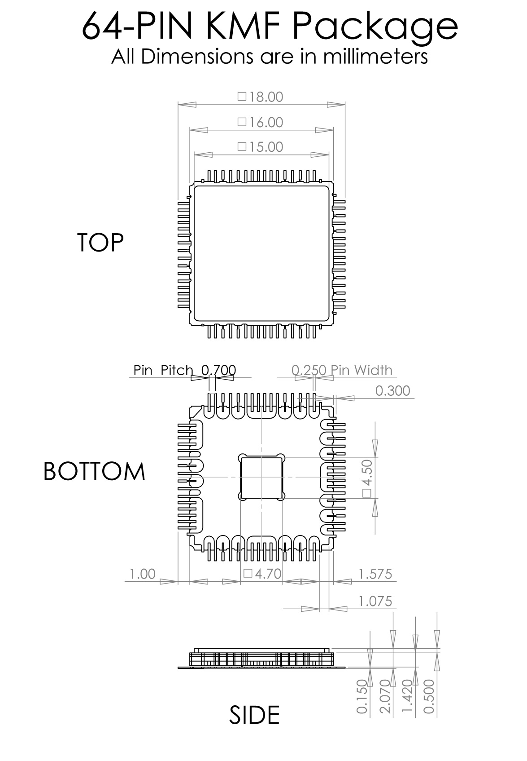
Fig. 8. CQFP 64-Pin Package Drawing (All Dimensions in mm)

REVISION HISTORY
Revision | Date | Changes
1.3.1 | 03-2017 | Added PAM4 eye diagrams
1.2.1 | 07-2016 | Corrected Table 2. Bits 8-14
1.1.1 | 02-2016 | 3wtrmoff function is removed from descriptions  Modified pin out diagram  Corrected block diagram  Corrected description of the 3-wire interface  Corrected terminal functions section  Corrected electrical characteristics table  Updated package information
1.0.1 | 04-2015 | Corrected pin out diagram  Corrected block diagram  Added description of 3wtrmoff function  Corrected Terminal Functions table  Corrected Electrical Characteristics table
1.0.0 | 09-2014 | Preliminary release

